

Software Design Document

Author(s): Mike Frascoia, Sarah Heredia, Sam Wright, Charlie Wallace
Affiliation: Radford University
Web Address: radford.edu/~softeng15
Date:11/16/2011

Revisions
Version | Primary Author(s) | Description of Version | Date Completed
1.0 | Sarah Heredia  Charlie Wallace | First version. | 11/16/2011

Review & Approval
Requirements Document Approval History
Approving Party | Version Approved | Signature | Date
Sarah Heredia
Sam Wright
Dr. T. L. Lewis

Requirements Document Review History
Reviewer | Version Reviewed | Signature | Date
Mike Frascoia
Charlie Wallace

Contents
1 Contents ii
2 Introduction 1
2.1 System Overview 1
2.2 Supporting Materials 1
2.3 Definitions and Acronyms 1
3 Functional Requirements Mapping Overview 3
4 High Level Design 4
4.1 Conceptual View (Architectural Context Model) 4
5 Low Level Design 5
5.1 Data Flow Diagram Model 5
6 User Interface Design 6
6.1 Application Control 6
6.2 Screen 1.. n 7
7 Final Schedule 17
8 Final Budget 20

Introduction

System Overview
Prestige Software is developing an Android application for students to access D2L from their mobile android device. This application will be designed to give students the ability to perform tasks that are not currently available on the D2L mobile website.

Supporting Materials
- The A-Team – Software Design Document (Dated: Nov 11, 2009)
- Dr. Tracy Lewis
- D2L Desktop Web Application (https://learn.radford.edu)
- D2L Mobile Website (https://learn.radford.edu/d2l/m/home)
- Microsoft Office Visio 2010
- Microsoft Office Project 2010
- Microsoft Word 2010/2011
- Adobe Photoshop CS5
- Titanium Appcelerator
- Appcelerator Kitchensink

Definitions and Acronyms
- D2L – Desire to Learn
- RU – Radford University
- The Team – Prestige Software
  - Mike Frascoia, Sarah Heredia, Charlie Wallace, Sam Wright
- Appcelerator – A platform for developing mobile, tablet and desktop applications using web technologies.
- GUI – Graphical User Interface

- API – Application Programming Interface
  - A particular set of rules (‘code’) and specifications that software programs can follow to communicate with each other. (http://en.wikipedia.org/wiki/Application_programming_interface)
- DB – Database

Functional Requirements Mapping Overview

Functional Requirement | Design Artifact
- The user shall be able to click on an icon from their list of downloaded applications to access the D2L application. | Figure 6.2.1 D2L Application Icon
- The application shall allow the user to login to the Desire2Learn system using their assigned username and password. | Figure 6.2.2 D2L Application Login Screen
- The application shall allow users to select a course from a list of courses in which the student is currently enrolled. | Figure 6.2.3 List of Enrolled Courses
- The application shall allow users to click on an icon to access course Grades, Dropbox or Content. | Figure 6.2.4 Screenshot of Course Utilities
- The application shall allow the user to check their grades in any of their current classes. | Figure 6.2.5 Screenshot of Course Grades
- The application shall allow the user to upload a file to their Dropbox and submit it for assignments. | Figure 6.2.6 Upload File to Dropbox Screenshot
- The user shall be able to download a file from Dropbox and content panes that will be opened with a built in file presentation system. | Figure 6.2.7 Download File from Dropbox Screenshot  Figure 6.2.8 Screenshot of File Downloaded from Dropbox
- The application shall allow the user to view and download files from Content. | Figure 6.2.9 Download File from Course Content Screenshot  Figure 6.2.10 Screenshot of File Downloaded from Content

High Level Design

Conceptual View (Architectural Context Model)

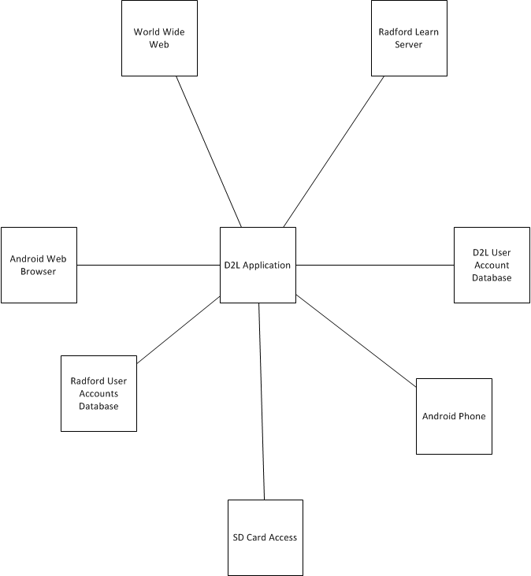

Low Level Design

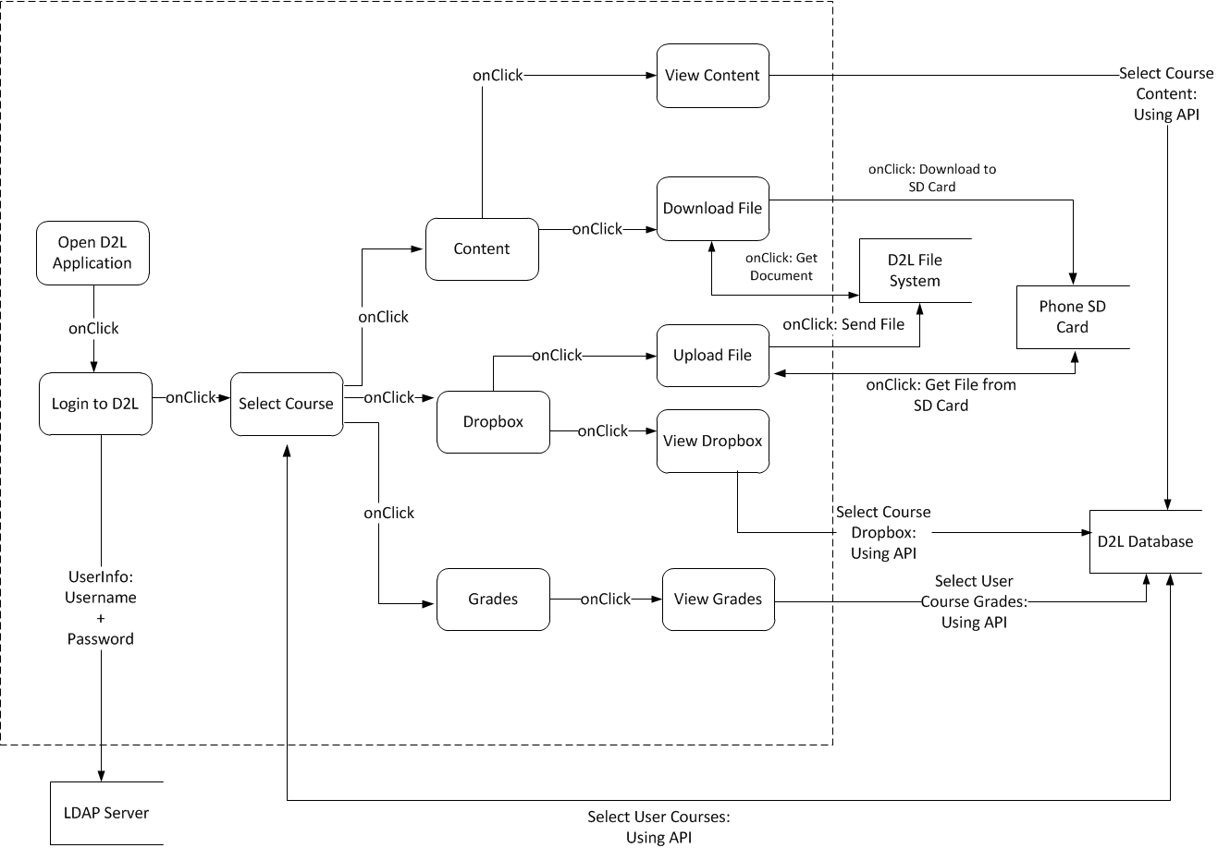
Data Flow Diagram Model

User Interface Design

Application Control
The user interface of the D2L application will have a color scheme containing the official Radford University school colors and a few hints of the D2L color scheme. The layout of the application will be a login screen that requires a form fill-in layout that requires the users’ current username and password. The remaining sections of the application will be comprised of a menu selection layout using buttons and hyperlinks to access documents or different pages. Upon successful login, the user will be supplied with a list of their current enrolled courses. The user shall be able to click on the desire course to be accessed and brought to a new screen containing a button for each utility supported by this application, namely Grades, Content and Dropbox. The user will also have the option to click a My Home button to return to their list of courses. Each utility for a given course will supply either read only information as in the Grades utility or the option to upload and/or download files as in Content and Dropbox. All of these options shall be supplied to the user at the click of a button. The user shall be required to use the Back button on their Android phone to navigate to a previous page in the application and the phones Home button to logout and exit the application.

Screen 1.. n
Figure 6.2.1 D2L Application Icon
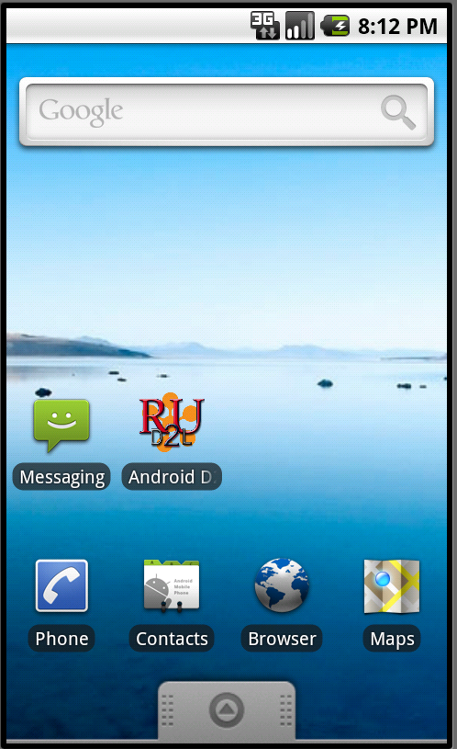

Figure 6.2.2 D2L Application Login Screen
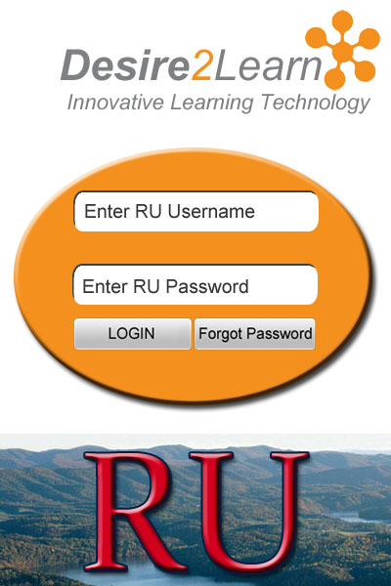

Figure 6.2.3 List of Enrolled Courses
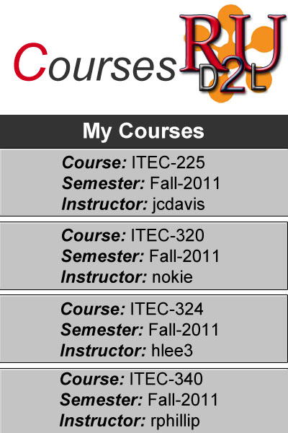

Figure 6.2.4 Screenshot of Course Utilities
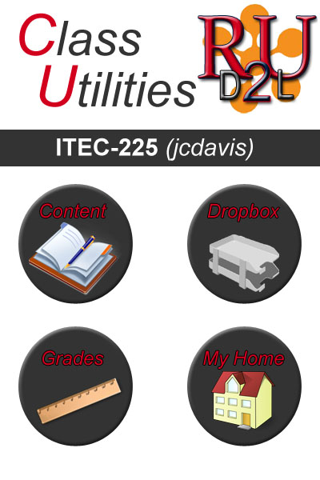

Figure 6.2.5 Screenshot of Course Grades
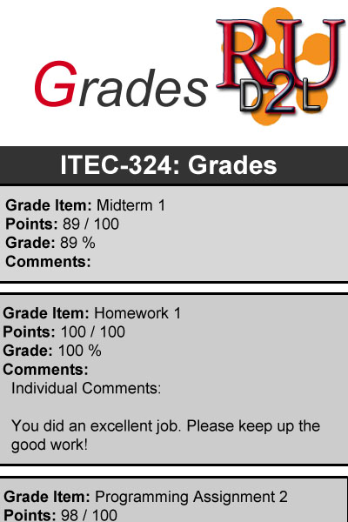

Figure 6.2.6 Upload File to Dropbox Screenshot

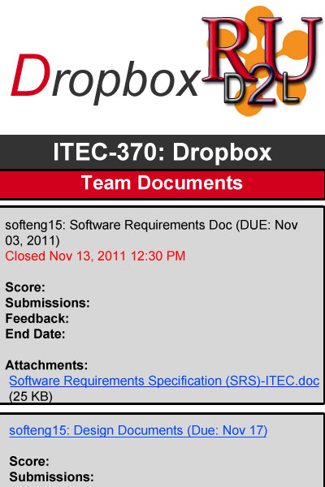

Figure 6.2.7 Download File from Dropbox Screenshot
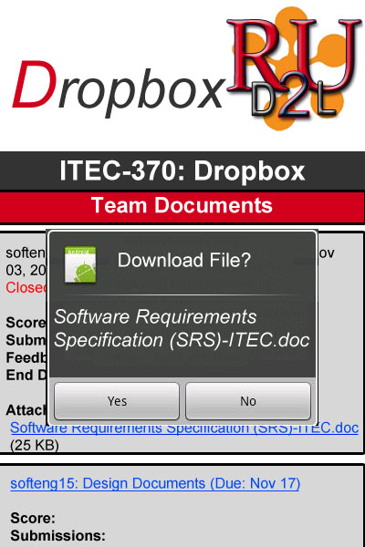

Figure 6.2.8 Screenshot of File Downloaded from Dropbox

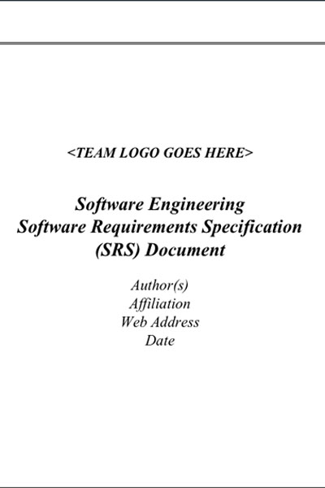

Figure 6.2.9 Download File from Course Content Screenshot

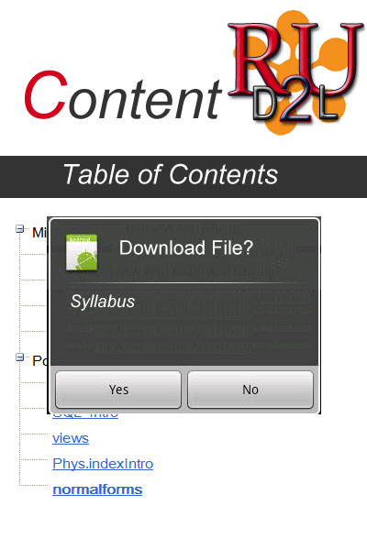

Figure 6.2.10 Screenshot of File Downloaded from Content

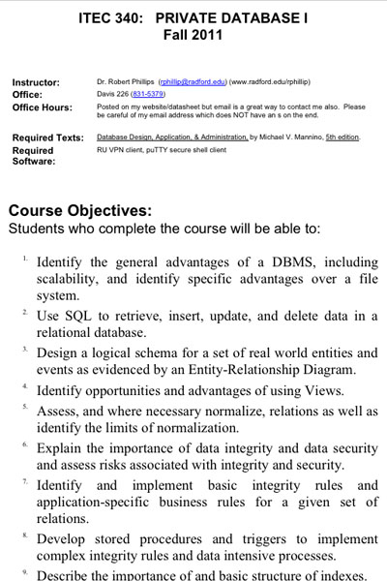

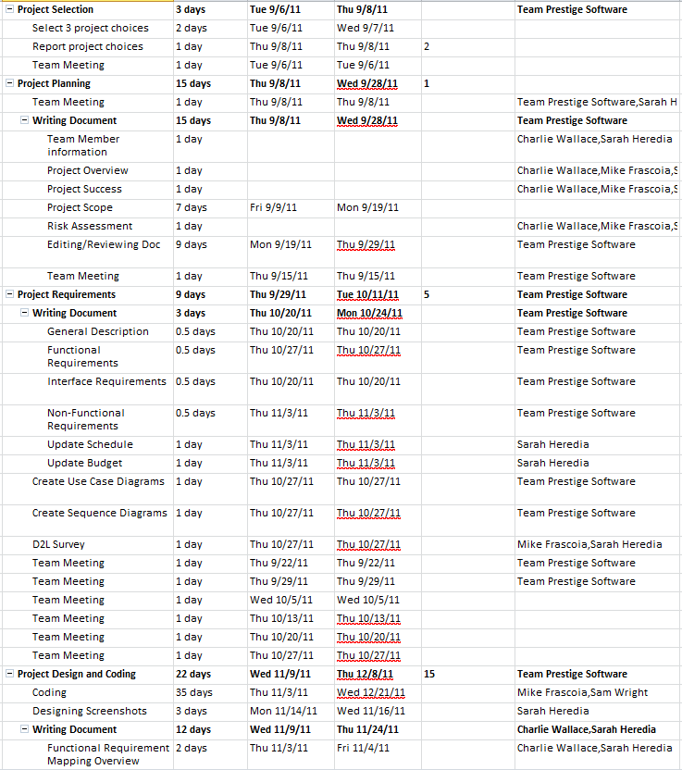
Final Schedule
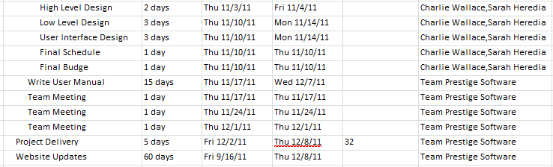
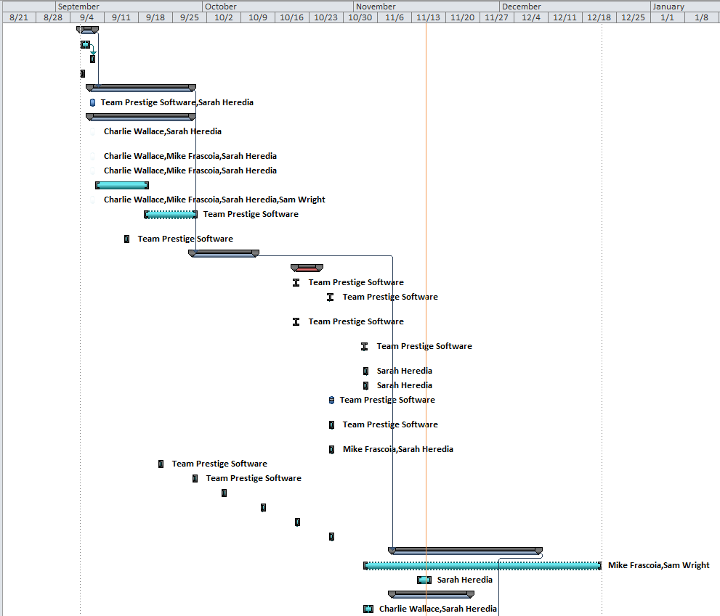
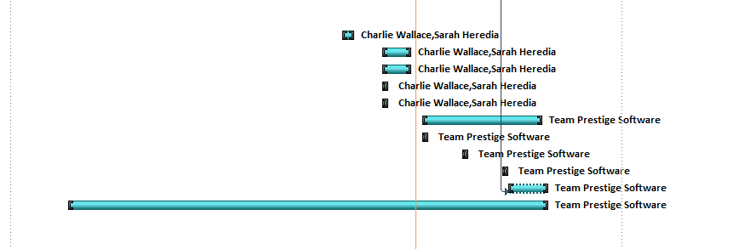

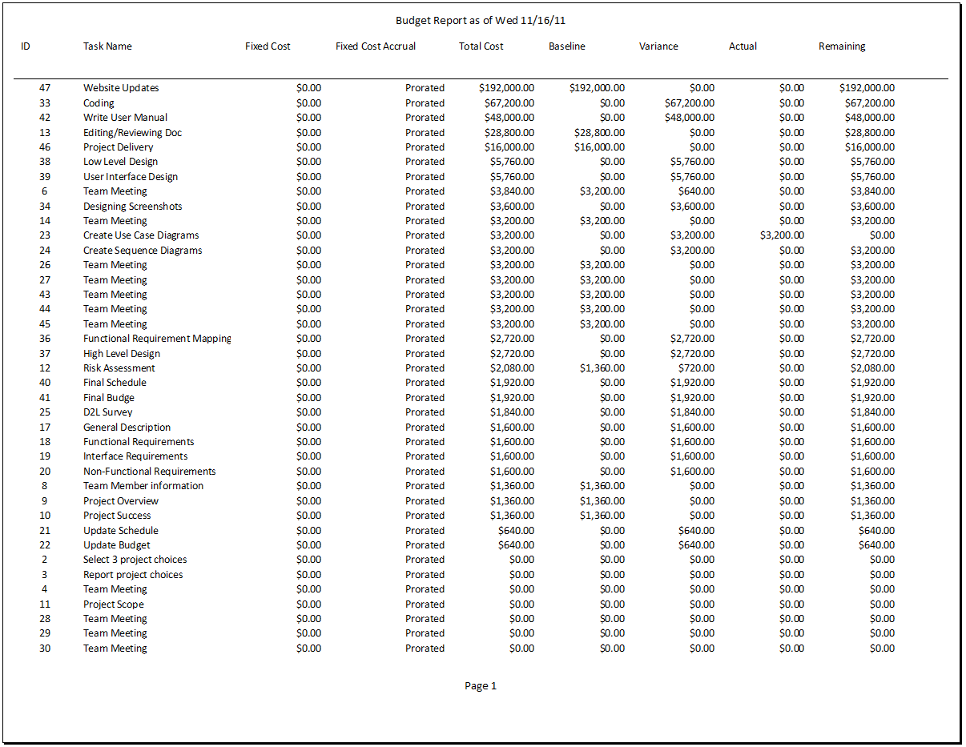
Final Budget

